Hair Restraints Training Material and Comprehension Quiz

- Policy
  - All persons who encounter processing equipment, dietary supplement contact surfaces, utensils, in-processing materials, raw materials, packaging materials and finished products ARE REQUIRED to wear hair restraints at all times
  - All visitors and guest of Longevity Nutra, Inc. abide by policy set forth on section 4 while visiting the premises.
  - Uniforms, including footwear, and hair coverings that are provided to employees in dietary supplement manufacturing sites are primarily for the protection of materials, work-in-progress (WIP), finished product and dietary supplement contact surfaces.
  - Employees and visitors must wear clean clothing, footwear, and hair covering, if identified as a risk, while in the processing area.
  - Hairnets and beard snoods are to be worn by employees working on the packing or processing line or who work around exposed product.

- Procedure
  - Equipment / Materials
    - Dispenser – Hairnets & Beard Covers
    - Hairnets
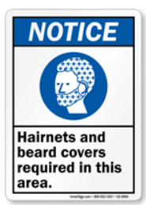
    - Beard Covers
    - Mirror – Stainless Steel
  - Requirements
    - Dispenser
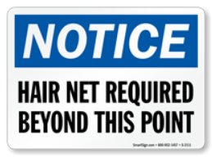
      - Must be cleanable.
      - Notice – Hairnets and Beard Covers
Reference: www.mysafetysign.com
      - Model / make / supplier
      - Item No.______________
      - Location: _________________
    - Mirror – Stainless Steel
      - Purpose is to visually inspect proper donning of PPE, hairnet
      - Reference: www.terrauniversal.com
      - Location: _________________
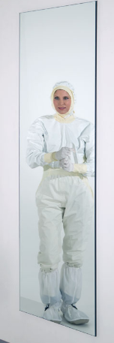
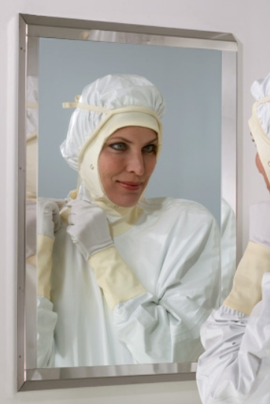

  - Beard Cover Donning
    - When donning beard cover ensure that the entire beard or facial hair is covered.
    - Once beard cover is donned, proceed to hairnet donning procedure.
    - Personnel with facial hair must perform this procedure first. Others proceed to section 2.4.
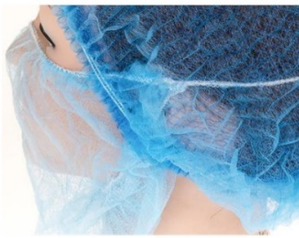

  - Hairnet Donning
    - Brush and tie the hair back as the hairnet elastic will lay flat against the neckline.
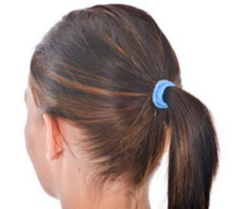

    - Hold the hairnet open ready for donning with the closure north to south.
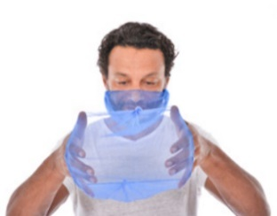

    - Locate across the forehead and pull the hairnet over the crown, ensuring all hair is covered.
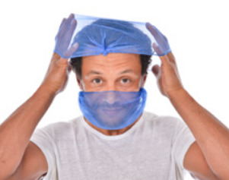

    - Locate under the ears and secure in place.
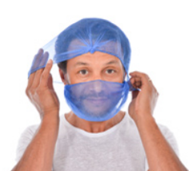

    - Check all hair is fully enclosed.



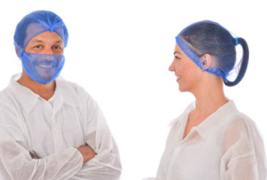
    - Use mirror or ask a colleague for visual check.

    - Put on lab coat and other PPE after hairnet has been worn. This ensures that any hair dislodged by donning and adjusting will not enter dietary supplement manufacturing areas.
  - Frequency
    - At any moment
      - All personnel abide by these procedures when performing their responsibilities
    - Daily
      - [ENTER POSITION TITLE - cGMP Team Lead]
      - Ensure consumables are inspected and available.
    - Monthly
      - PCQI / QC / Maintenance / Facility Personnel
        - Verify dispenser station security, integrity and functionality.
        - Document all discrepancies and corrective actions on Corrective Action & Preventive Action Form.
        - Repair or replace dispenser as necessary.
    - Annual
        - [ENTER POSITION TITLE - cGMP Team Lead]
        - Verify training records
        - Train / Retrain personnel

- Responsibility
  - All Personnel

    - Required to don hair restraints when encountering processing equipment, dietary supplement contact surfaces, utensils, in-processing materials, raw materials, packaging materials and finished products.
  - Housekeeping / Designated Department Personnel

    - Ensure hairnets and beard covers are replenished, dispensers refilled, and available along with the approved consumables (Hairnets, Beard Covers, Gloves, Soap, Disposable Paper Towels, Sanitizer, Disinfecting Agents, Trash Bin Liners) frequently as necessary
  - [ENTER POSITION TITLE – cGMP Team Lead]

    - Inspect hairnets and beard covers are available on all PPE locations.
    - Ensure hairnets and beard covers utilized by personnel are intact (no tears, rips or missing pieces)
    - Visually inspect personnel for compliance of this policy.
    - Ensure personnel are trained on this policy and procedures.
  - Supervisors or Department Heads and Team Leaders

    - Ensure (inspect) and verify this policy and procedure is adhered to and;
    - Ensure (inspect) and verify that consumables (Hairnets, Beard Covers, Gloves, Soap, Disposable Paper Towels, Sanitizer, Disinfecting Agents, Trash Bin Liners) are refilled and replaced frequently.
  - Quality Control Personnel

    - Validate consumables (Hairnets, Beard Covers, Gloves, Soap, Disposable Paper Towels, Sanitizer, Disinfecting Agents, Trash Bin Liners) are refilled and replaced frequently.
    - Validate training and adherence to policy and procedure.
    - Monitor and document non-conformance observation, also known as discrepancy, using Corrective Action and Prevention Action Form.
  - QC / Compliance Department

    - Document all records.
    - Maintain document control and archive.

- Corrective Action
  - Train all personnel on this policy.
  - Non-compliance will require re-training or dismissal from job duties or termination of employment.
  - Removal of an employee from direct dietary supplement contact to non-dietary supplement contact activities when the employee does not comply with the policy.
  - GMP retraining and familiarization course / lesson.

- Review - Quality
  - Annual review of company policies on clothing including uniforms, gloves, hairnets, snoods and footwear if all are in place and are appropriate for the type of operation.
  - Ensure items such as hair nets, snoods and disposable gloves are available at accessible locations at the start of each shift.
  - Check disposable gloves and hairnets are correctly disposed of every after end of shift.

- History
Revision No.: | Revision Date: | Description of Change: | Originator/Author Name: | Title / Department:
0 | 20240531 | Original | [ENTER AUTHOR NAME] | [ENTER TITLE/ENTER DEPARTMENT]

Requirements:
- The trainee (employee/visitor) has read or received a verbal translation of all or part of the policy, procedure, method, and/or SOP for which they are being trained.
- The trainee has observed a demonstration of the task they are to perform or the procedure for which they are being trained as required.
- The trainee has demonstrated the ability to perform the task with acceptable proficiency and minimal supervision.

TRAINEE (Print Name): | TRAINEE (Signature): | Date: | Department:
Trainer / Supervisor (Print Name): | Trainer (Signature): | Date: | Department:

NAME (Print): | Date:

Hair Restraints Comprehension Quiz

Direction: Choose the best answer and encircle the letter.

- A piece of fine mesh fabric for confining the hair.
- Hairnets and beard cover
- Hair Cap
- Hair Ponytail

- How often should personnel abide by these procedures when performing their responsibilities?
- At any moment
- Daily
- Monthly

- How often is the availability of consumables inspected?
    - At any moment
    - Daily
    - Monthly

- Put on the lab coat and other PPE before the hairnet has been worn. This ensures that any hair dislodged by donning and adjusting will not enter dietary supplement manufacturing areas.
    - True
    - False

- Who is responsible for document control and archiving?
- Housekeeping
- QC / Compliance Department
- Quality Personnel

